Project Objectives

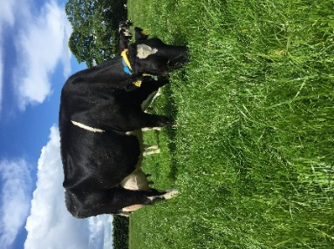
- To develop a sustainable high-output grass-based spring milk production system
- To incorporate the most recent advances in grassland management for dairy farms into a high- output system
- Use a type of dairy cow that has good genetic indices for both milk production and fertility
- Employ the best practices from nutrition research and dairy cow husbandry
- Incorporate nutritional studies into a high-output system
- To incorporate management technologies and system attributes that enhance the sustainability of dairy production

Farm Details Week 03/04/23
Stocking rate on MP (LU/ha) | 3.15
Farm Cover (DM/ha) | 804
Growth Rate (DM/ha/day) | 31
Grass demand (DM/ha/day) | 42
Average Concentrate fed (kg/day) | 8
Average DIM | 43
Area Grazed (%) | 82

Cow Details Week 27/03/23
Yield (kg/cow/day) | 33.20
Fat (%) | 4.22
Protein (%) | 3.29
MS (kg/day) | 2.58
SCC | 68
Cows calved | 56/57

Grassland Management:
As of the 3rd of April, 82% of the milking platform has been grazed. Due to adverse weather conditions, cows were grazing for 5 days (27-31/03) and allocated 12 kg DM/cows/day and offered silage ad lib for 2 days over the weekend. Cows are getting 8 kg of concentrate per day. Cows are back at pasture (03/04/23) full time with the aim to finish the first rotation by the 9th of April depending on ground conditions.

Comments:
Calving started on the 26th of January and 98% of cows (56/57) have calved to date. As of the 30th of March, 54/57 cows were BCS which reported that 89% (48) of the cows were within the normal range of 2.75-3.25 with 4 cows thin and 1 heifer at 3.5. The 4 thin cows are being milked once a day while still being offered concentrate twice a day to build condition ahead of the breeding season.

For more details on the High Output Systems Research Herd visit
https://www.ucd.ie/agfood/about/lyonsresearchfarm/lyonsdairyherd/

